**EFS(Elastic File System)**

1. First we need to create Security group for EFS

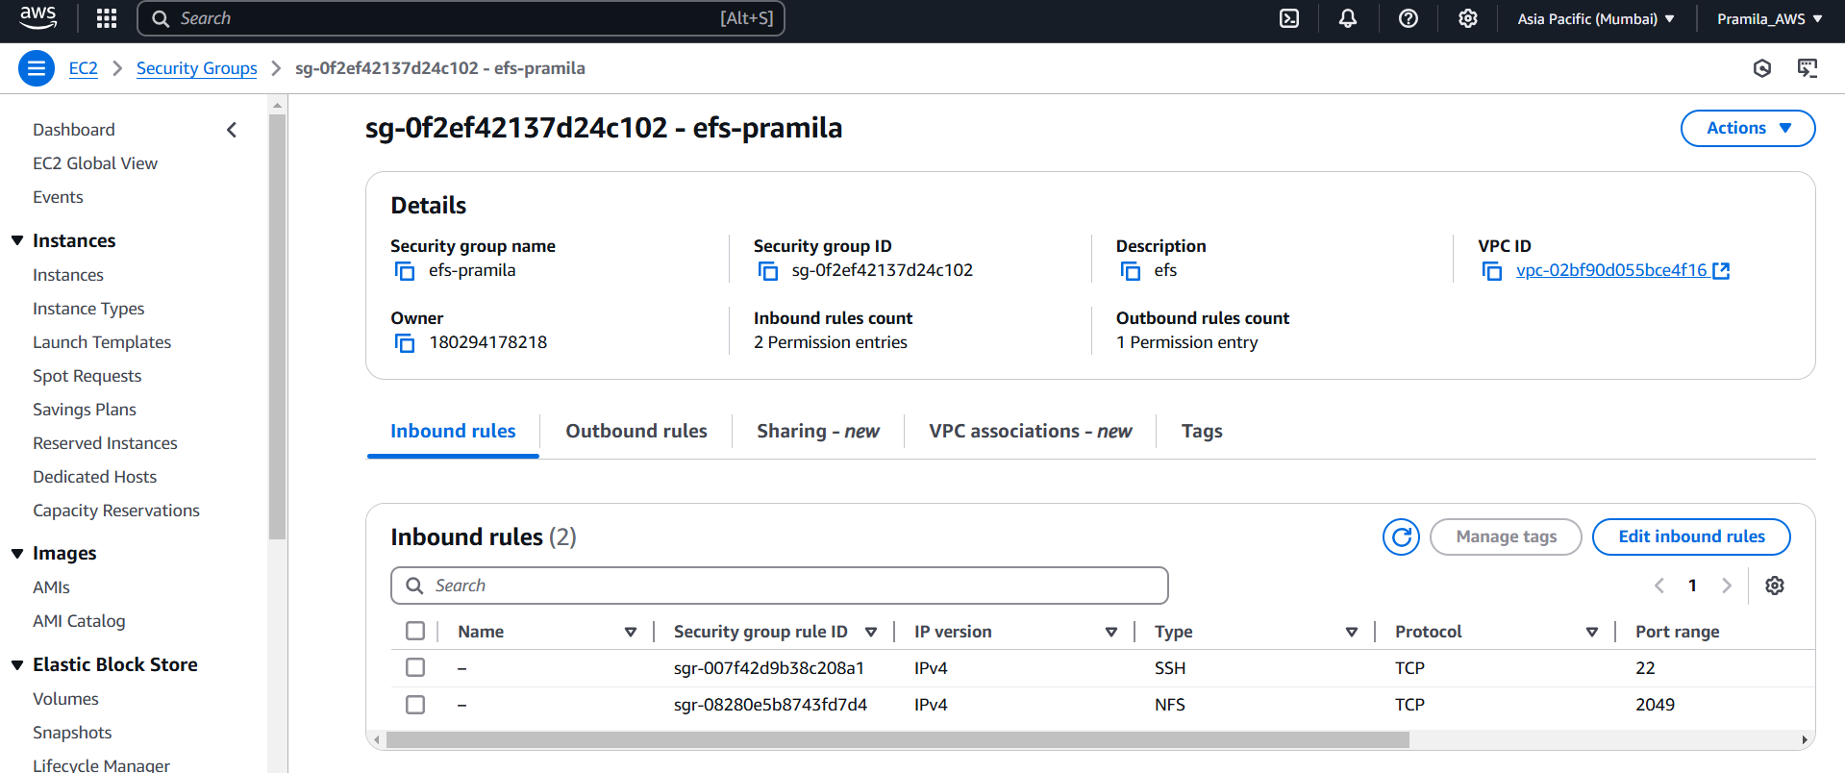

1. Create EFS

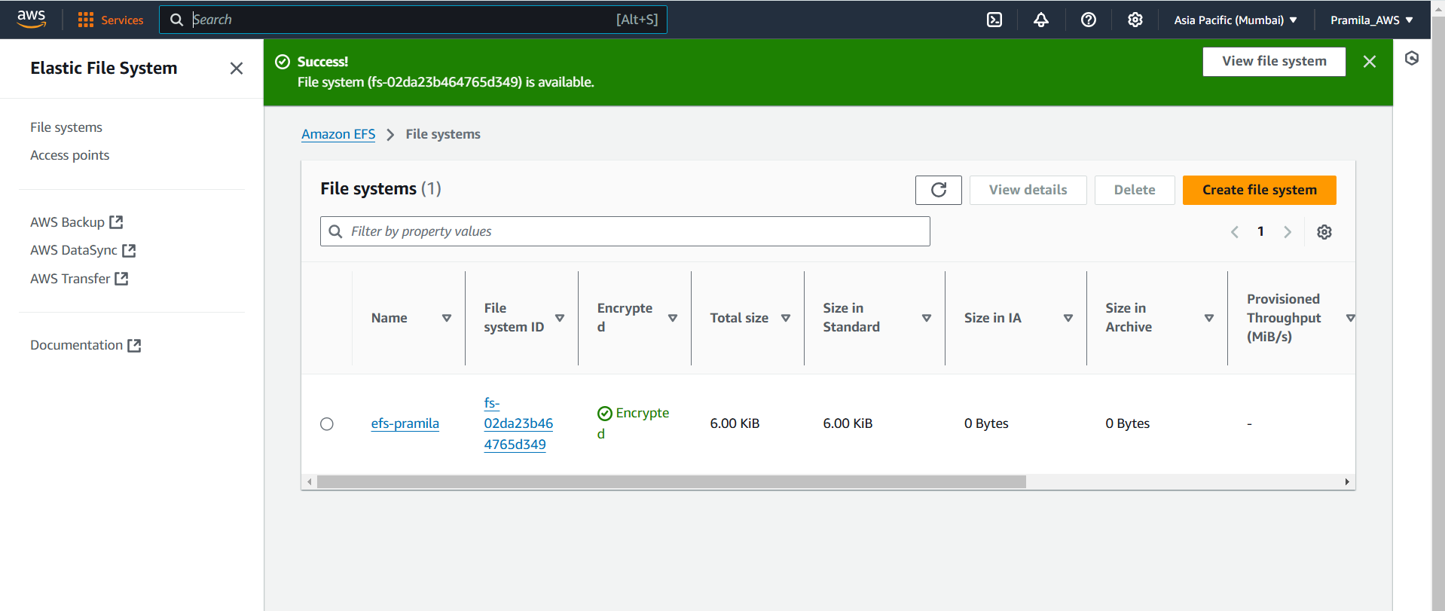

1. Create instance with same security group

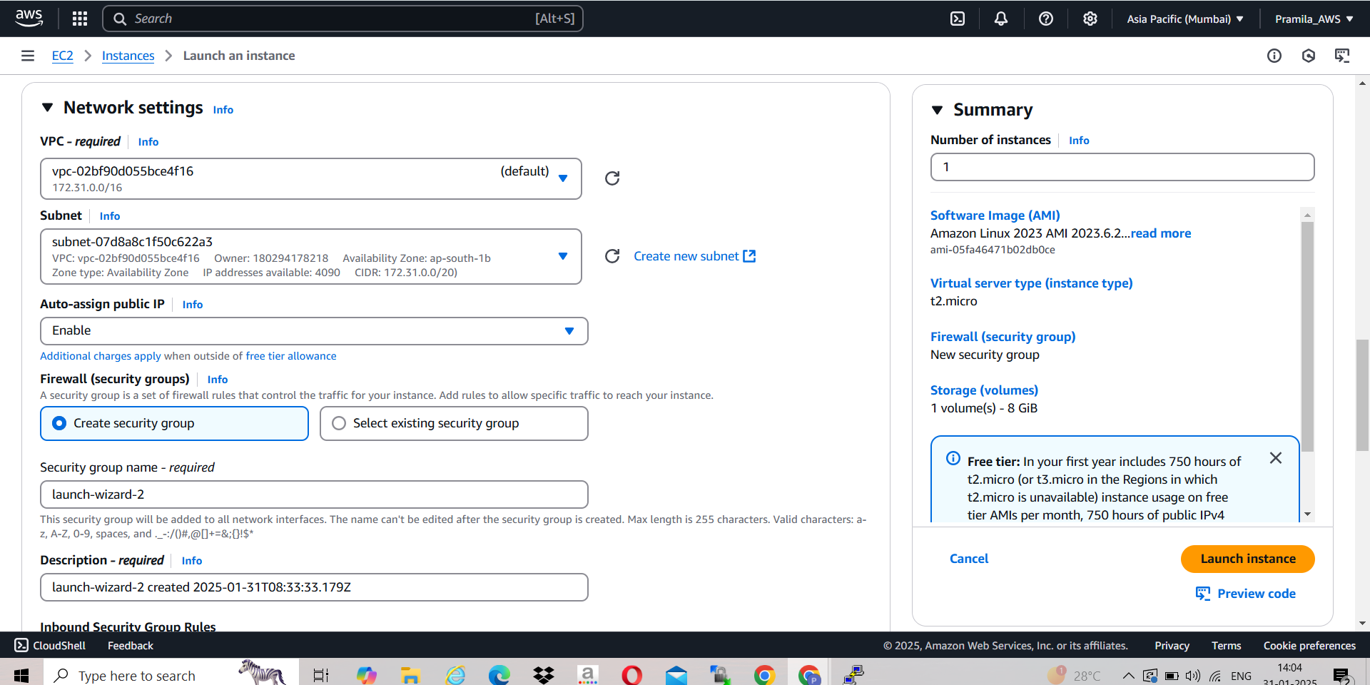

1. Created instance with 2 different Availability zones

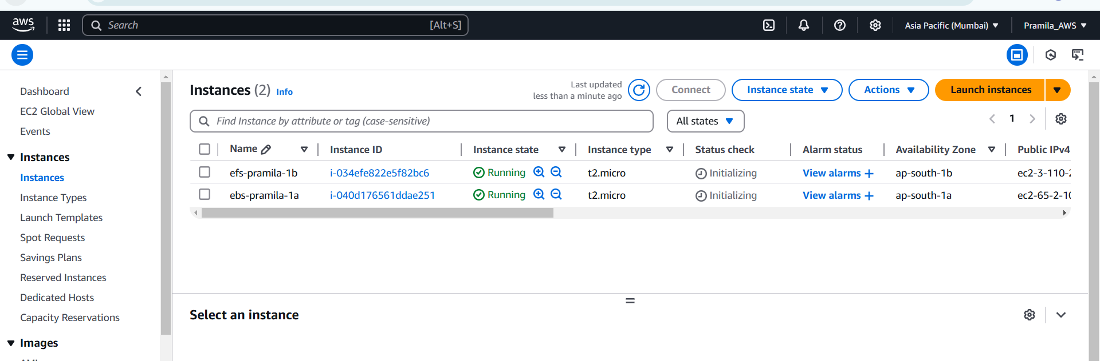

1. Login in instances using putty

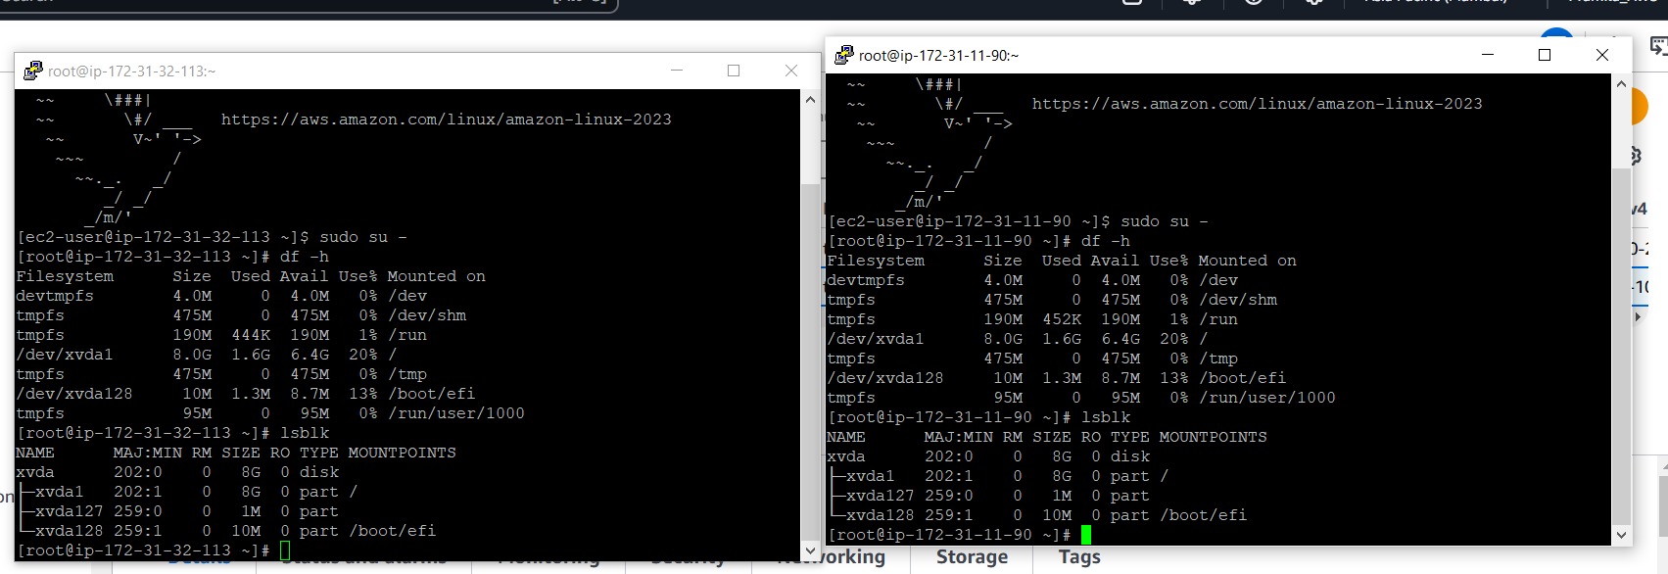

1. Mount EFS using below command on both the instances of different AZs



1. Created file in one instance and add some data

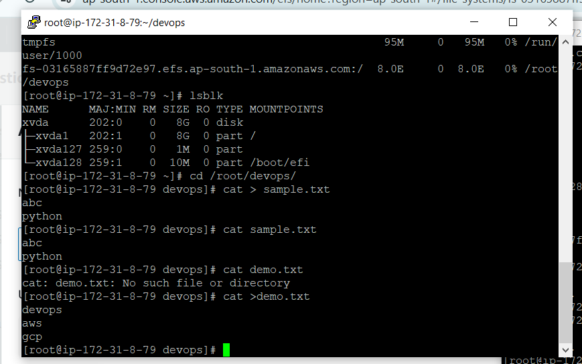

1. That file is visible in second instance which havinf same EFS is mounted

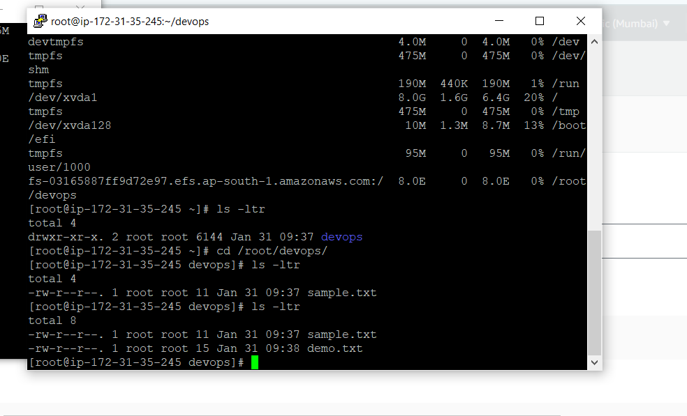

1. Same data is also present in that file

